S3 BUCKET REPLICATION

CLICK S3 IN SEARCH BAR
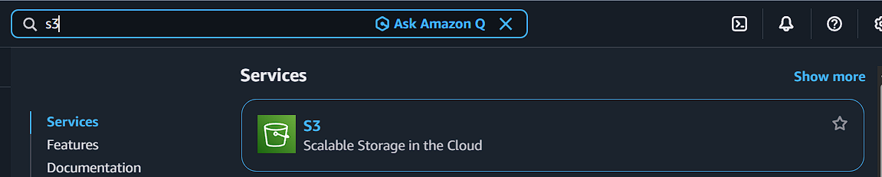
CLICK CREATE
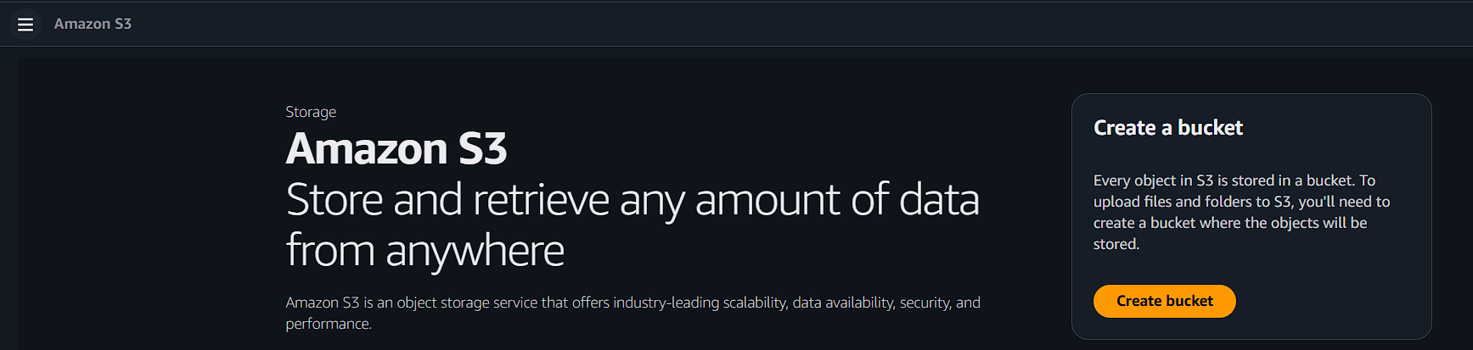
ENTER BUCKET NAME
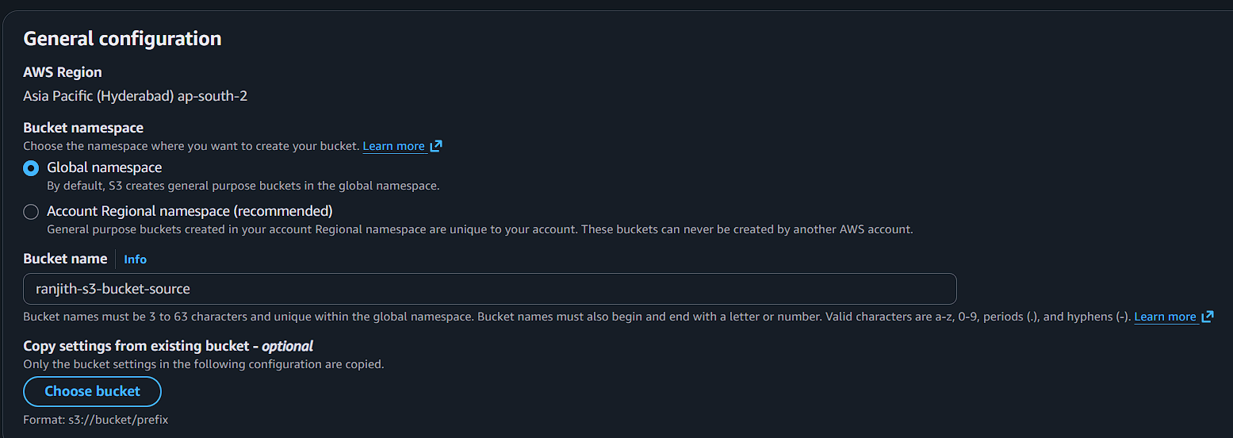
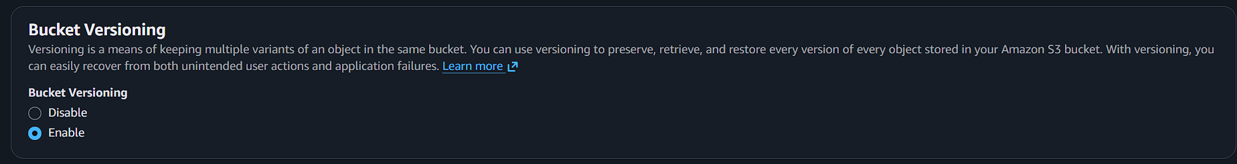
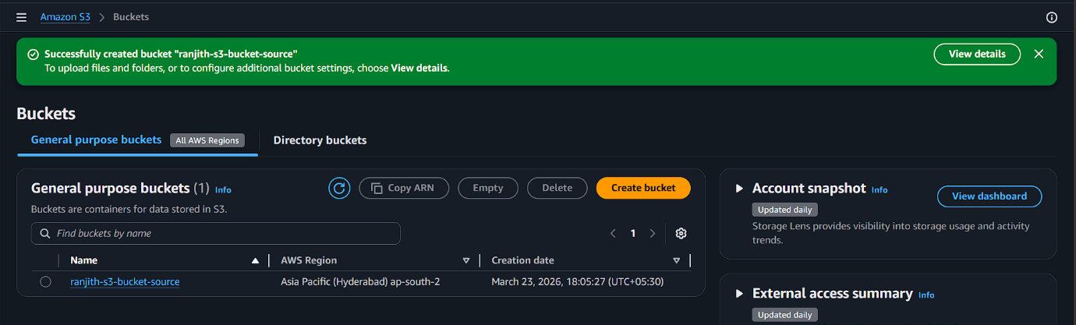

CREATE ANOTHER BUCKET

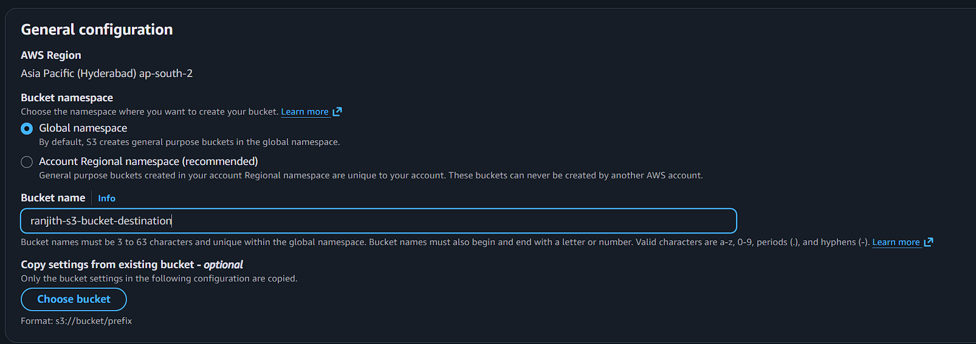

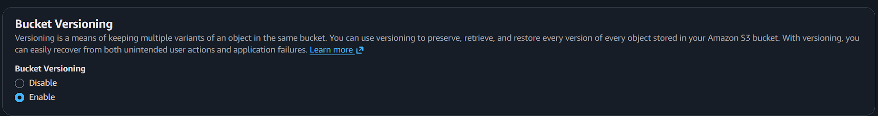

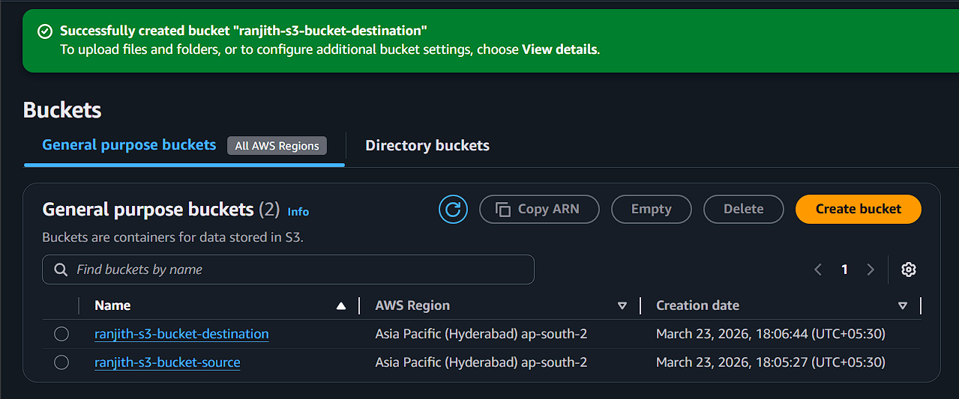

CLICK SOURCE BUCKET AND GO TO MANAGEMENT
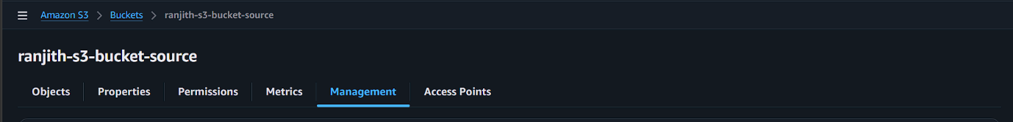

SCROLL DOWN AND CLICK CREATE REPLICATION RULE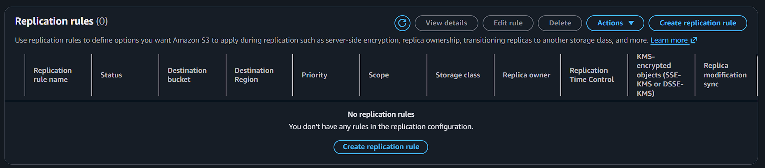

ENTER RULE NAME
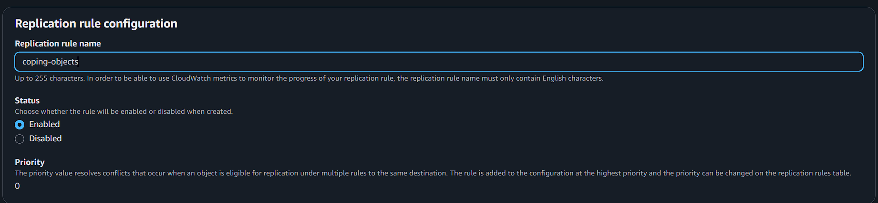
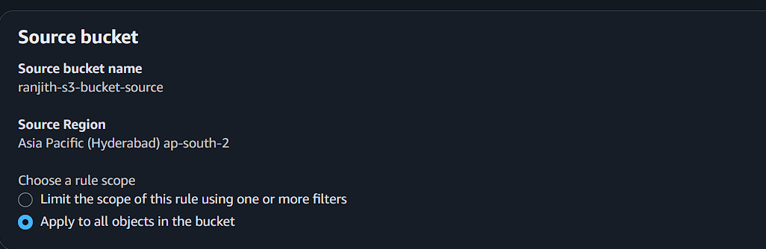
SELECT DESTINATION BUCKET
(ENTER NAME OR BROWSE(ITS ONLY WORKED FOR OWN REGION BUCKET) )
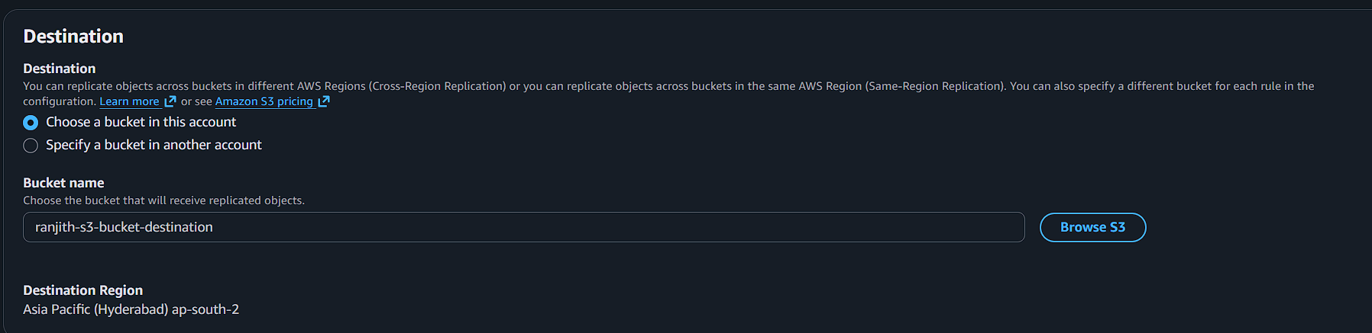

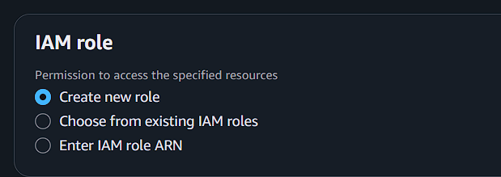
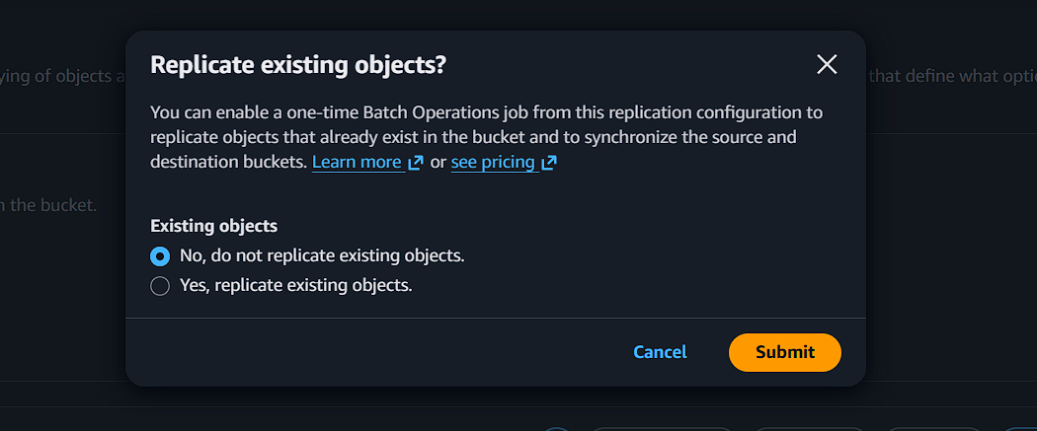

NOW UPLOAD OBJECTS
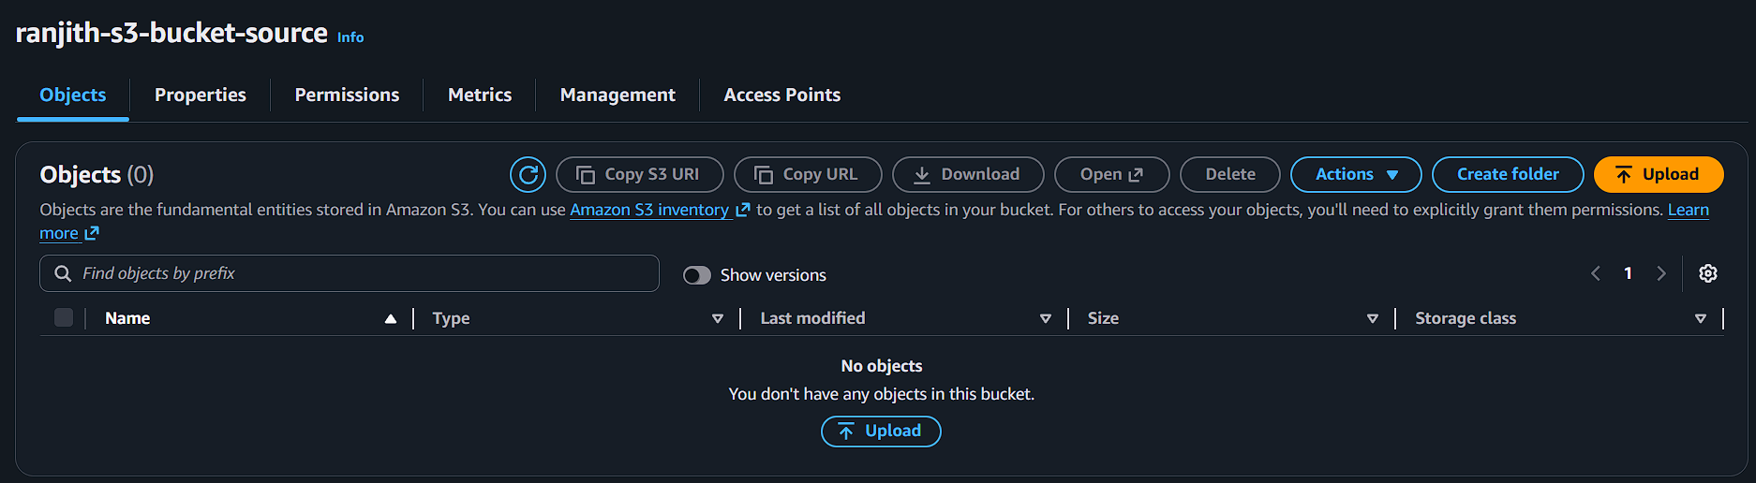
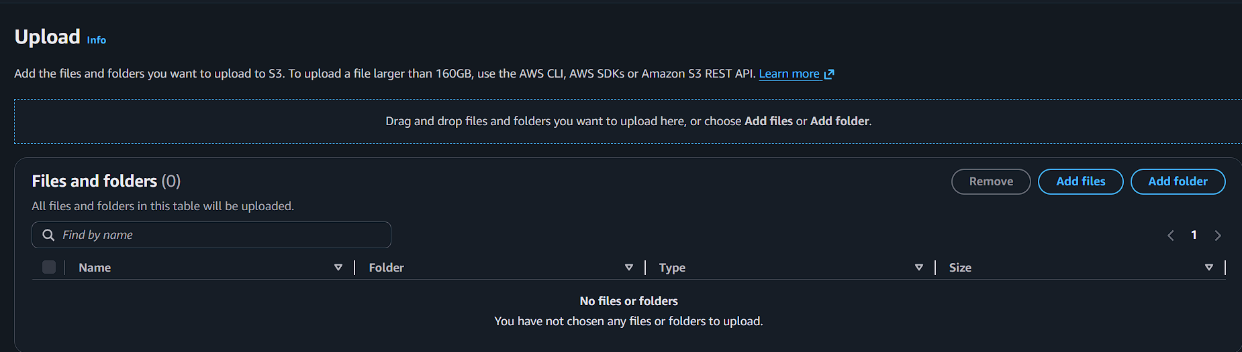
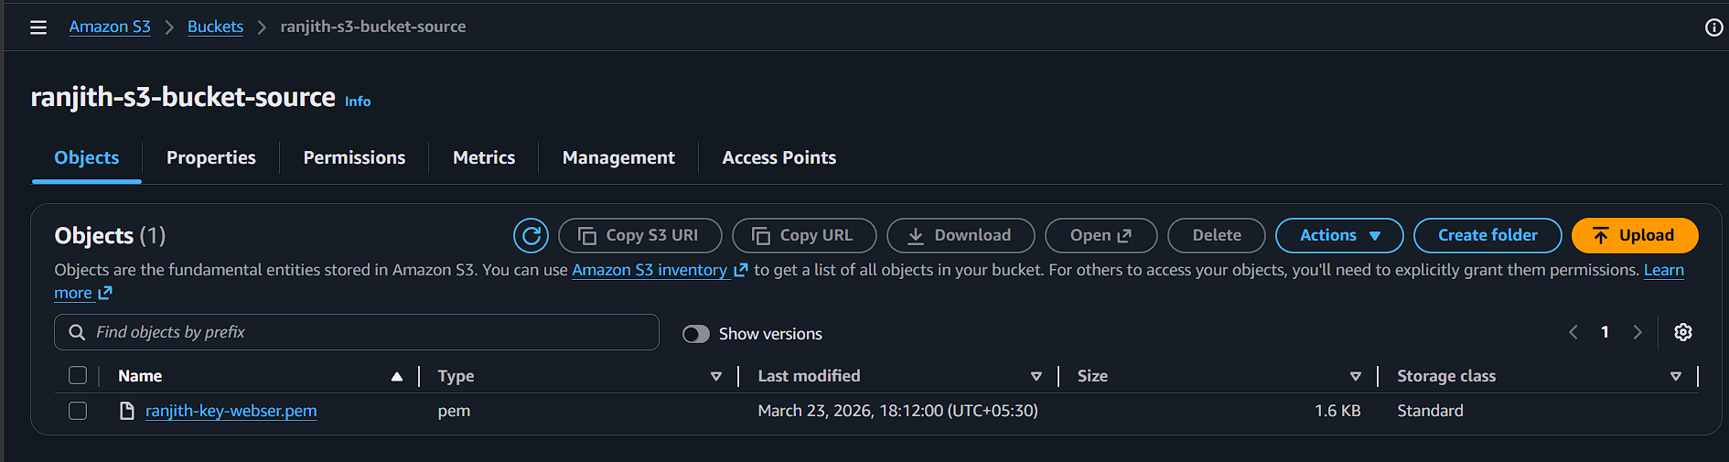

CHECK THE DESTINATION BUCKET
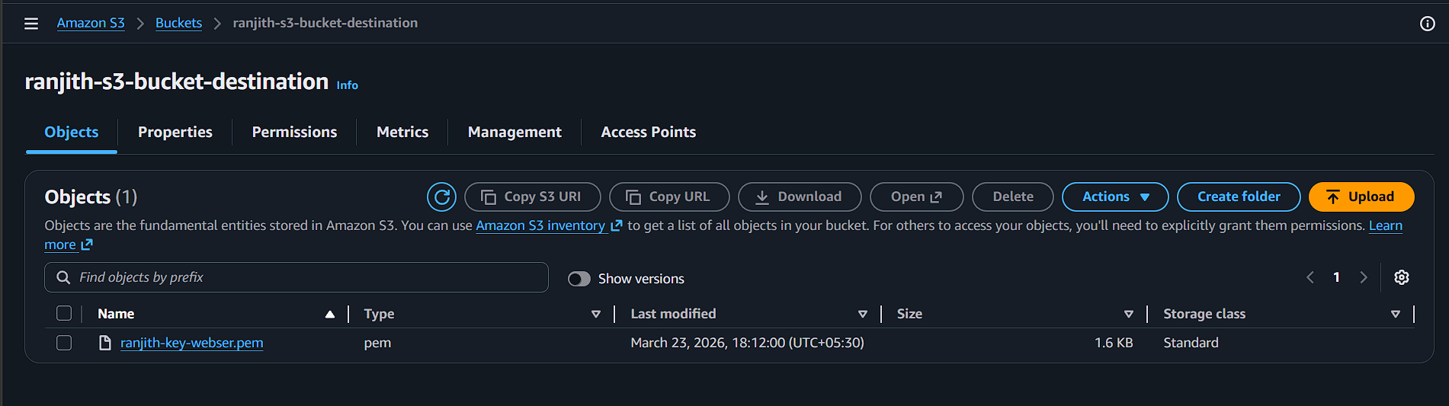

ONCE MORE ADD ANY OBJECTS
